Total Score:

Question

a)

b)

c)

d)

e)

f)

g)

h)



**ANL252**

**PYTHON FOR DATA ANALYTICS**

**Tutor Marked Assignment**

Semester 1 Term 1

TG Group: 09

Name: Michael Cheng Lee Beng

SUSS PI Number: B1981656

Date of Submission: 15 August 2021

(a)

import math

(b)

# default values mean and variance is 0 and 1 respectively unless user enters a value

a = 0

b = 1

# user input for mean

mean = (input("Enter the value of mean between positive and negative infinity: "))

# validating user input

(c)

while mean:

if not mean.isnumeric() and mean!='':

print("Please enter a numeric value!")

mean = (input("Enter the value of mean between positive and negative infinity: "))

else:

break

# user input for variance

variance = (input("Enter the value of variance larger than 0: "))

# validating user input

while variance:

if not variance!=''and variance.isnumeric() :

variance = (input("Enter the value of variance larger than 0: "))

print("Please enter a numeric value!")

elif float(variance)<=0 and variance.isnumeric():

variance = (input("Enter the value of variance larger than 0: "))

print("Invalid value entered!")

else:

break

# user input for x

x = (input("Enter the value of x between positive and negative infinity: "))

# validation of user input

while x:

if not x!="" and x.isnumeric():

x = (input("Enter the value of x between positive and negative infinity: "))

print("Please enter a numeric value!")

else:

break

# if user doesn't enters any value, assign default value of mean

if mean == '':

mean = float(a)

mean = float(mean)

print("Mean ", mean)

x = float(mean)

variance = float(variance)

mean = float(mean)

# if user doesn't enters any value, assign default value of variance

if variance=='':

variance=float(b)

variance = float(variance)

print("Variance ", variance)

x = float(x)

print("x ",x)

def fx():

if x==0 and mean==0:

i = 0

h = 0

else:

i = math.e**(-((x*x - mean*mean)*(x*x - mean*mean))/2*variance)

h = math.sqrt(2*math.pi*variance)

# if either of numerator or denominator is 0, value of function becomes 0

if i==0 or h==0:

funtion1 = 0

else:

funtion1 = i/h

funtion1 = round(funtion1, 4)

# display the final value of the function

print("Probability function is ", funtion1)

fx()

**OUTPUT is as follows:**

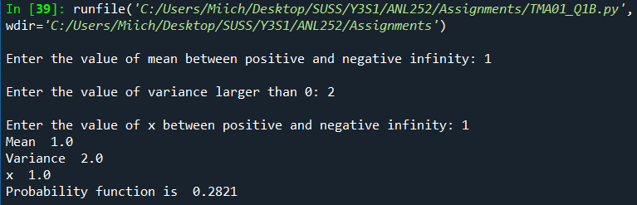

# default values mean and variance is 0 and 1 respectively unless user enters a value

a = 0

b = 1

negative_inf = -10.0

alpha = 0.1

# user input for mean

mean = (input("Enter the value of mean between positive and negative infinity: "))

# validation of user input

while mean:

if not mean.isnumeric() and mean!='':

print("Please enter a numeric value!")

mean = (input("Enter the value of mean between positive and negative infinity: "))

else:

break

# user input taken for variance

variance = (input("Enter the value of variance larger than 0: "))

# validatation of user input

while variance:

if not variance!=''and variance.isnumeric() :

variance = (input("Enter the value of variance larger than 0: "))

print("Please enter a numeric value!")

elif float(variance)<=0 and variance.isnumeric():

variance = (input("Enter the value of variance larger than 0: "))

print("Invalid value entered!")

else:

break

# user input taken for x

k = (input("Enter the value of k between positive and negative infinity: "))

# validation of user input

while k:

if not k!="" and k.isnumeric():

k = (input("Enter the value of x between positive and negative infinity: "))

print("Non numeric value entered!")

else:

break

# if user doesn't enters any value, assign default value of mean

if mean == '':

mean = float(a)

mean = float(mean)

print("Mean ", mean)

# if user doesn't enters any value, assign default value of variance

if variance=='':

variance=float(b)

variance = float(variance)

print("Variance ", variance)

k = float(k)

print("k ",k)

def function(k_1):

k=float(k_1)

if k==0 and mean==0:

i = 0

h = 0

else:

i = math.e**(-((k*k - mean*mean)*(k*k - mean*mean))/2*variance)

h = math.sqrt(2*math.pi*variance)

# if either of numerator or denominator is 0, value of function becomes 0

if i==0 or h==0:

func_k = 0

else:

func_k = i/h

func_k = round(func_k, 4)

return func_k

k = float(k)

negative_inf = float(negative_inf)

print("Negative infinity value: ", negative_inf)

alpha = float(alpha)

print("Alpha value: ", alpha)

num = negative_inf

result = 0.0

d = dict()

while num<=k:

result += function(num)

result = alpha*result

d[round(num, 4)] = round(result, 4)

num += alpha

# display the final value of the function

print("Probability function is ", result)

for key in d:

print(key, end=" ")

print(d[key])

OUTPUT as follows:

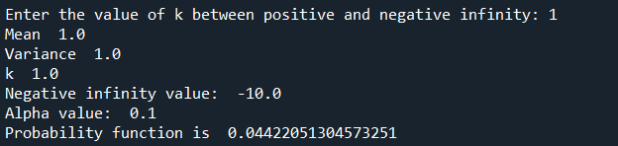

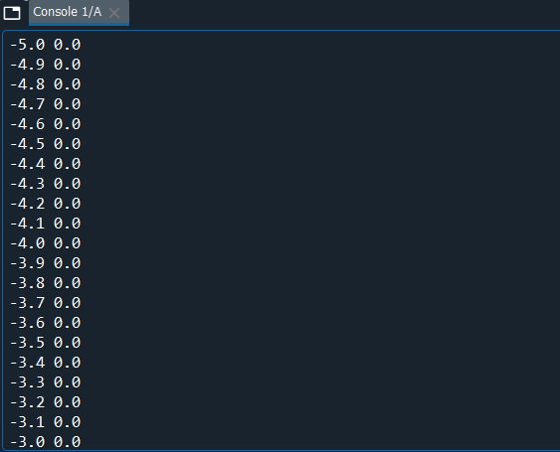

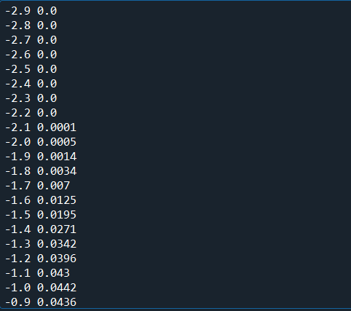

(g)

I first begin importing the math library. Following that, I declare and initialize a variable to hold the value of negative infinity and alpha. Users would then be required to input values for mean, variance and x. On top of that, I have put in some validations such as the If-else statement, while loops in the codes to ensure that there are restrictions placed. For examples, there are validations to ensure that variance is more than 1, if the variance inputted is less than 1, users would then be prompted to re-enter a value more than 0.

The function(k_1) calculates the probability function and returns the probability function.

import math

# default values mean and variance is 0 and 1 respectively unless user enters a value

a = 0

b = 1

neg_infty = -10.0

alpha = 0.1

# user input for mean

mean = (input("Enter the value of mean between positive and negative infinity: "))

# validation

while mean:

if not mean.isnumeric() and mean!='':

print("Please enter a numeric value!")

mean = (input("Enter the value of mean between positive and negative infinity: "))

else:

break

# user input taken for variance

variance = (input("Enter the value of variance larger than 0: "))

# validating user input

while variance:

if not variance!=''and variance.isnumeric() :

variance = (input("Enter the value of variance larger than 0: "))

print("Please enter a numeric value!")

elif float(variance)<=0 and variance.isnumeric():

variance = (input("Enter the value of variance larger than 0: "))

print("Invalid value entered!")

else:

break

# user input taken for x

k = (input("Enter the value of k between positive and negative infinity: "))

# validating user input

while k:

if not k!="" and k.isnumeric():

k = (input("Enter the value of x between positive and negative infinity: "))

print("Non numeric value entered!")

else:

break

# if user doesn't enters any value, assign default value of mean

if mean == '':

mean = float(a)

mean = float(mean)

print("Mean ", mean)

# if user doesn't enters any value, assign default value of variance

if variance=='':

variance=float(b)

variance = float(variance)

print("Variance ", variance)

k = float(k)

print("k ",k)

def function(k_1):

k=float(k_1)

if k==0 and mean==0:

i = 0

h = 0

else:

i = math.e**(-((k*k - mean*mean)*(k*k - mean*mean))/2*variance)

h = math.sqrt(2*math.pi*variance)

# if either of numerator or denominator is 0, value of function becomes 0

if i==0 or h==0:

func_k = 0

else:

func_k = i/h

func_k = round(func_k, 4)

return func_k

k = float(k)

neg_infty = float(neg_infty)

print("Negative infinity value: ", neg_infty)

alpha = float(alpha)

print("Alpha value: ", alpha)

num = neg_infty

result = 0.0

d = dict()

while num<=k:

result += function(num)

result = alpha*result

d[round(num, 4)] = round(result, 4)

num += alpha

# display the final value of the function

print("Probability function is ", result)

for key in d:

print(key, end=" ")

print(d[key])

Question 1(g)

I first begin importing the math library. Following that, I declare and initialize a variable to hold the value of negative infinity and alpha. User would be required to input value for mean, variance and x. In addition, there are validations put in place to ensure that variance is more than 1, and ensure that the user input is all in numeric value. If the input is not in numeric value, users are required to re-enter a numeric value before proceeding to input the next value.

The calculate() function is used to calculate the numerator and denominator of the given formula. It also calculates the probability function by taking the numerator dividing by the denominator. As such, it returns the probability function.